The AWARD Leadership Program for Emerging African Women in Science
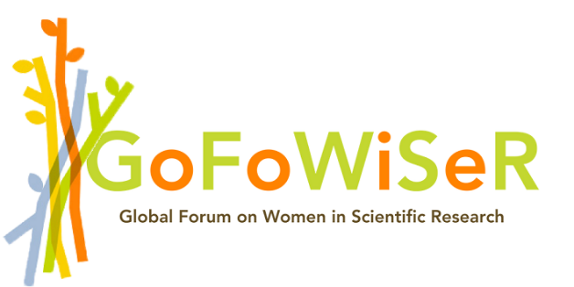

FREQUENTLY ASKED QUESTIONS

Q: How can I access the application form?
A: Application for the AWARD Leadership Program for Emerging African Women in Science is only via an online form available on the AWARD website.
Q: How do I confirm that my application got through?
A: The online platform automatically saves your work as you navigate through the application form.
Q: Is it possible for me to make any changes to my application after I submit it?
A: No, all submitted applications are final and cannot be amended through the online system or via email.
Q: I would like to apply, but I am not within the age limit. Can I still submit my application?
A: No. Applicants must be 35 years old or less before the application deadline. Successful candidates will be required to provide identification documents to verify their age.
Q: I would like to apply, but my country is not included in the list. Can I still submit my application?
A: No, you are not eligible to apply. The call targets specifically young African women scientists from Benin, Burkina Faso, Cote d’Ivoire, Ethiopia, Ghana, Kenya, Malawi, Mali, Nigeria, Senegal, Tanzania, Togo, Uganda, and Zambia

